Billing
- Your water bill will be mailed at the end of each month and will be due by the 10th of the following month.
- You can pay your bill in our office between the hours of 8 a.m. – 4 p.m. Monday – Friday, or use the drop box located beside our office door. You may also pay your bill at United Community Bank or Bank OZK any time before the 10th of the month. Go to www.notlawaterauthority.org for online payment options.
- The 3% convenience fee for credit card payments have been waived at this time; but Notla Water reserves the right to re-instate this fee should the need arise in the future.
- Automated Bank Draft is available at this time. Payments will be drafted between the 5th and 8th of every month. Forms to apply for this service are available at the office or you can download the form from our website. If you choose to use an online check writing company, please reference your account number on the check.
- We greatly appreciate the return of the barcode half of your water bill with your payment.
- When buying a home on our system on or before the 15th of the month, you will be responsible for the next minimum bill.

Water Meter & Water Lines
- Please familiarize yourself with your water meter. Your meter is usually located on either side of your driveway. If you are unable to locate it, our maintenance department will be happy to flag your meter for you.
- Customers are responsible for their line that runs from the meter to the house. We recommend installing a customer shutoff valve on the customer supply line to the house.
- Notla Water will maintain the meter and the line servicing that meter.
- Your water meter is read monthly. If the reading registers unusually high, Notla Water will attempt to contact you to confirm usage.
- We highly recommend that you turn your meter off (and the shut-off valve at your house) when leaving for extended periods of time.
- Notla Water cannot regulate nor guarantee water pressure on the customer’s side of the meter; therefore, the Authority highly recommends that all customers protect their plumbing with a properly sized pressure reducing valve (purchased and installed at the customer’s expense).

Freezing Temperatures
- When temperatures drop below freezing, pipes that are in unheated areas can freeze. Water expands as it freezes, causing pipes to break. A broken pipe can run 8 gallons per minute which can cause thousands of dollars in damages very quickly.
- Most common breaks from freezing occur in places that are exposed to the cold, such as outdoor water spigots, crawlspaces, basements, etc.
- On extremely cold days, remember to let your cold water drip from faucets that are fed by exposed pipes. Running water will help prevent pipe from freezing.
- If you are a customer who leaves for winter, turn your meter off and use the shut-off valve at your house. This protects you from having leaks while you are away.
- Make sure you know where your shut-off valves are located and that they are in good working order.
- Drain water from sprinkler systems, pools and hose bibs in winter.
- Insulate your exposed water pipes.
- Seal off any areas around your house where cold air can come in contact with your piping. The smallest opening can let cold air in and potentially cause pipes to freeze.

Leaks
- To check for a leak: Make sure no water is being used in the house (dishwasher, hung-up commode, etc.). Go to water meter and see if the SLOW LEAK INDICATOR (the silver wheel encased by red needle marker) is turning. If the indicator is turning and no water is being used in the house, there is a leak between the meter and the house.

5/8” X 3/4" MASTER METER Water Meter with Backflow Preventer

The picture below shows an example of a meter set:

¾” MASTER METER Water Meter
Curb-Stop is used to turn meter on or off. Do not tamper with this if locked by the Authority or you may be subject to fees and/or damages.
Backflow Preventer (check valve) keeps water from going back through the meter.

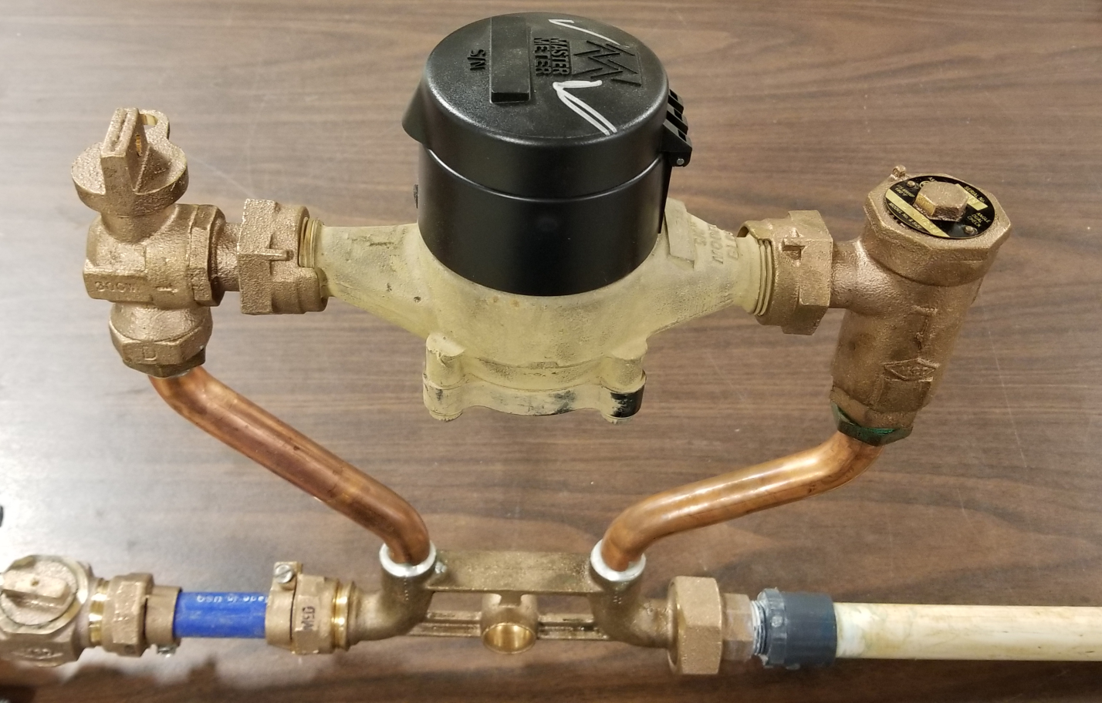
Notla Water Service Line brings water from the main to the meter.
Customer’s Service Line starts here and takes water to the house.

Meter (ERT) Number
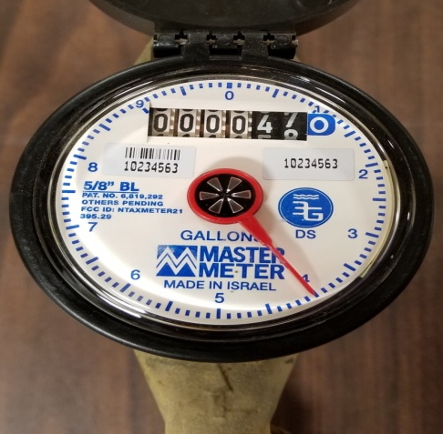
¾” MASTER METER Water Meter
To check for a leak: Make sure no water is being used in the house (commode, dishwasher, etc). Go to water meter and see if the SLOW LEAK INDICATOR is turning. If the indicator is turning and no water is being used, there is a leak between the meter and the house.
Slow-Leak Indicator Wheel

