How to Set Up Auto Pay

To Set Up Auto Pay for the 10th
- From your Dashboard, click on Auto Pay button, if you wish to set up auto pay for the due date of the 10th, then click on Enable Auto Pay
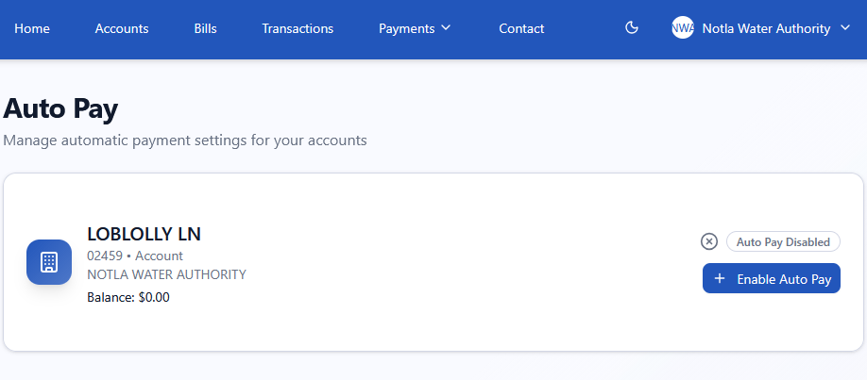

- Click on Add new Credit Card and enter your card information, click on Submit, then Done
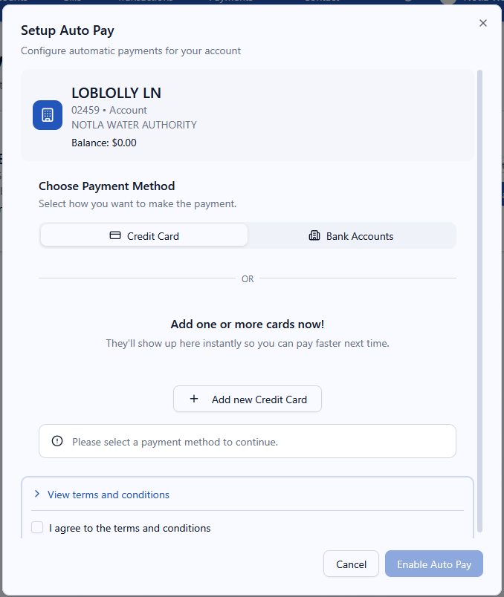
- Click on the Credit Card icon to highlight, then click Next Step, then Review Step
- View Terms and Conditions, and check the box to agree, and press Enable Auto Pay
- Your bill balance will automatically be charged to your credit card on the 10th of each month

To Set Up Auto Pay for a Scheduled Date
- From your Dashboard, under Quick Actions, select Schedule Payment
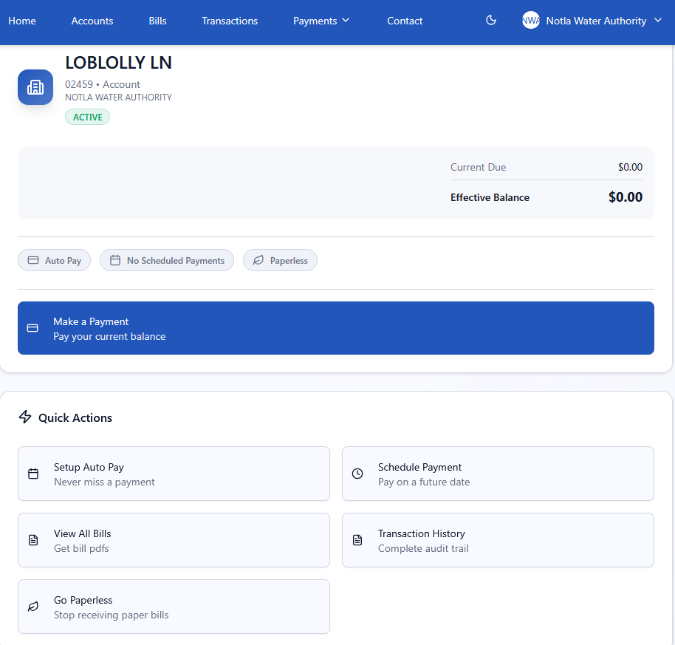

- Click on Create your First Scheduled Payment
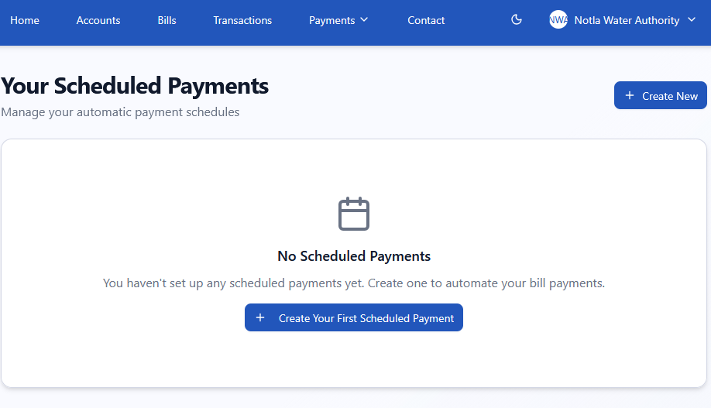
- Select Recurring Payment and use the up & down arrows to select a date before the 10th
- Do not enter an End Date
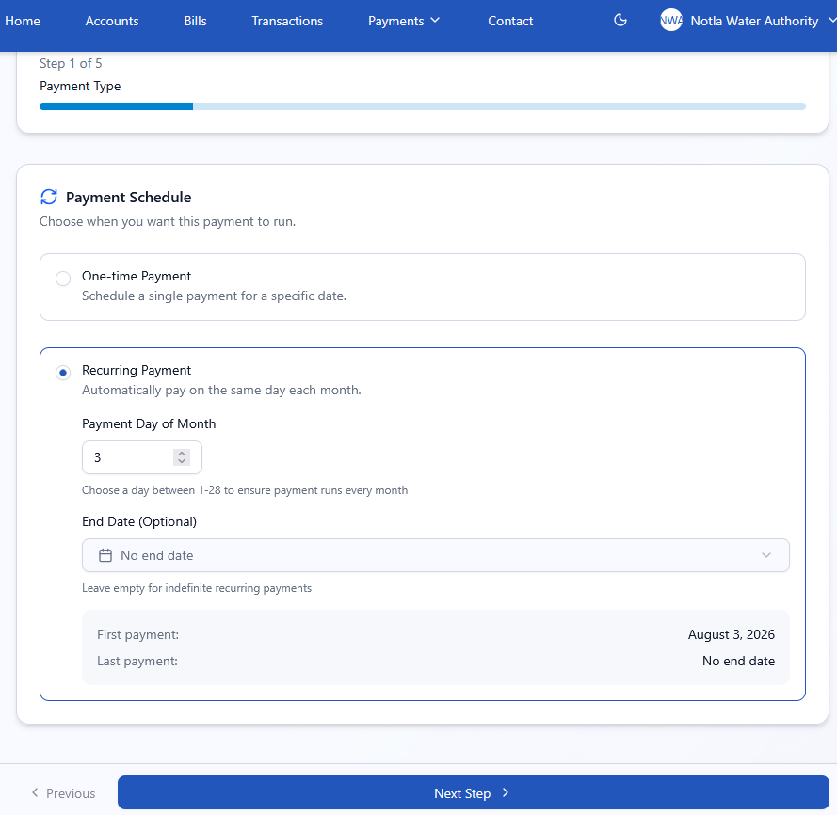

- Click on Next Step
- Select Pay Bill Balance
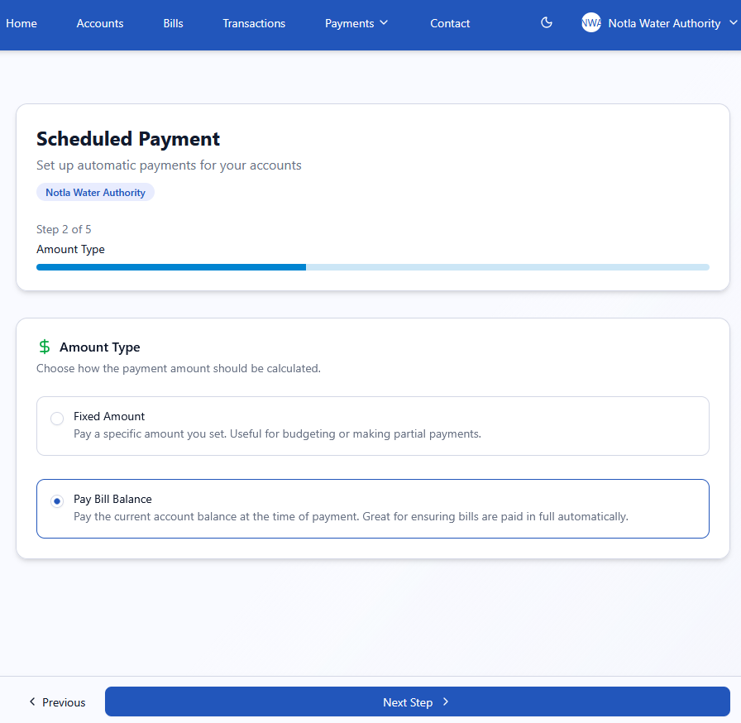
- Choose the account you with to set this up for (click on toggle switch to highlight)
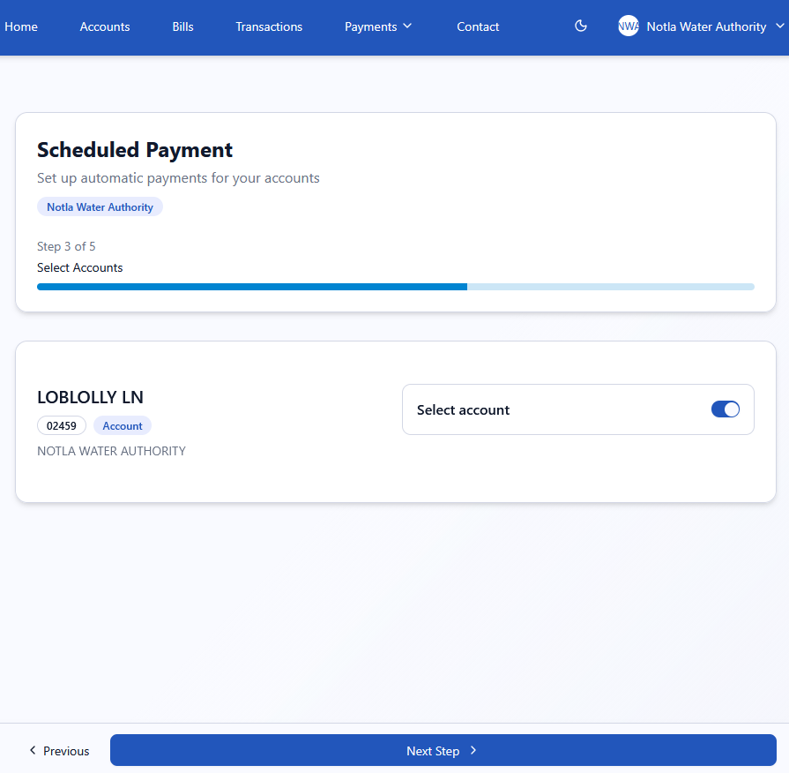

- Click on Add new Credit Card and enter your card information, click on Submit, then Done
- Click on the Credit Card icon to highlight, then click Next Step, then Review Step
- View Terms and Conditions, and check the box to agree, and press Enable Auto Pay
- Your bill balance will automatically be charged to your credit card on the date you set up

